Manual Test Plan

**Game Functions:**

1. Run game.py, it will create a pygame window with animation of gems dropping down.

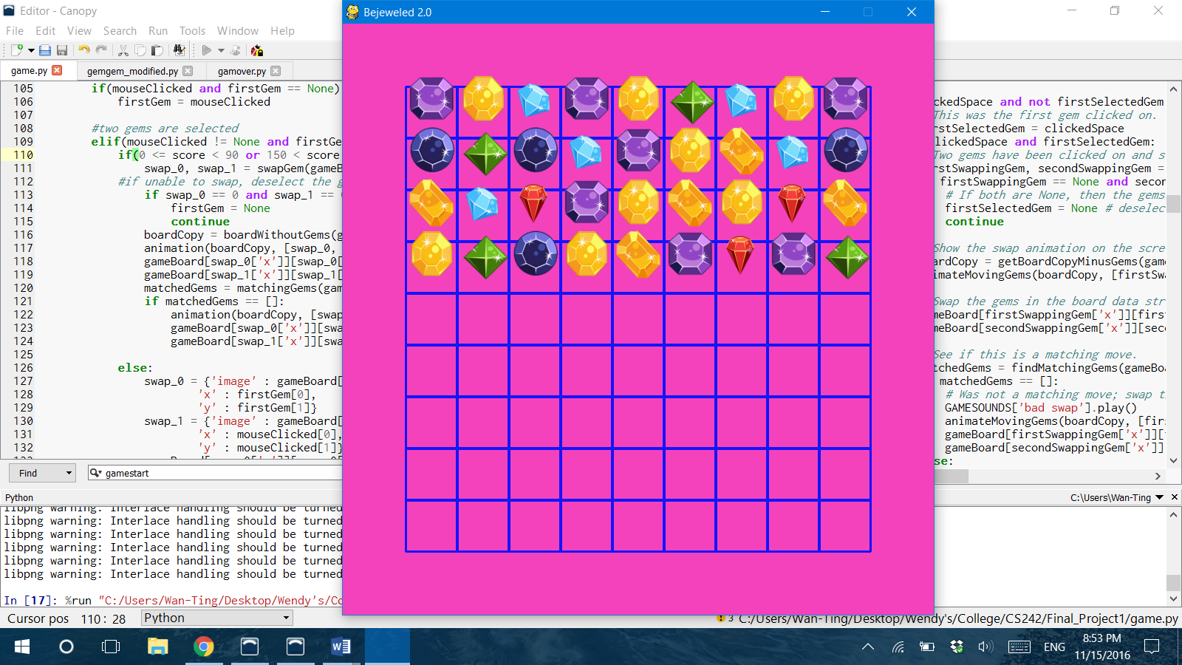

1. Click the first gem, it will highlight the square as shown below. Swap it with any gems in the four directions of the clicked gem. If the second clicked gem is not swappable with the first one, the highlight will disappear. Click any two gems to swap to create a link of three or more identical gems, the link will then disappear.

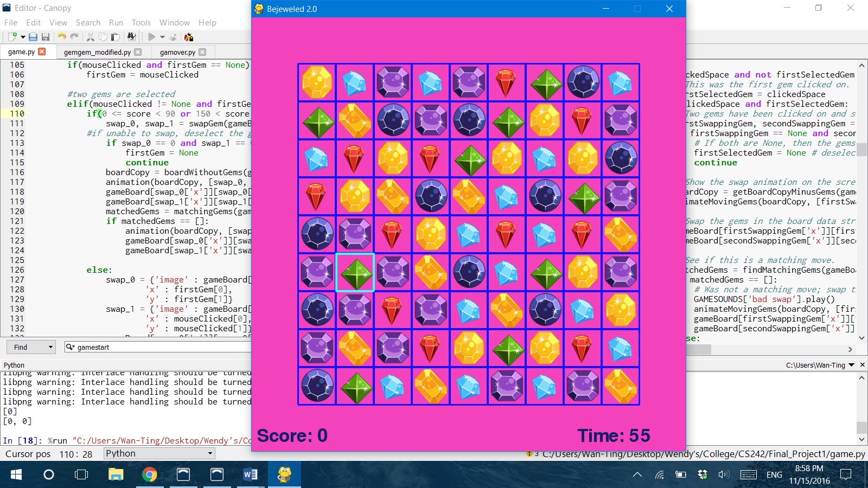

1. Score is updated according to the length of the link and how much time has left. Chain of 4 or more will automatically add 10 secs to the time.

Ex: chain of 3, 56 sec remained = (3 * 10) * (1 + 56/100)

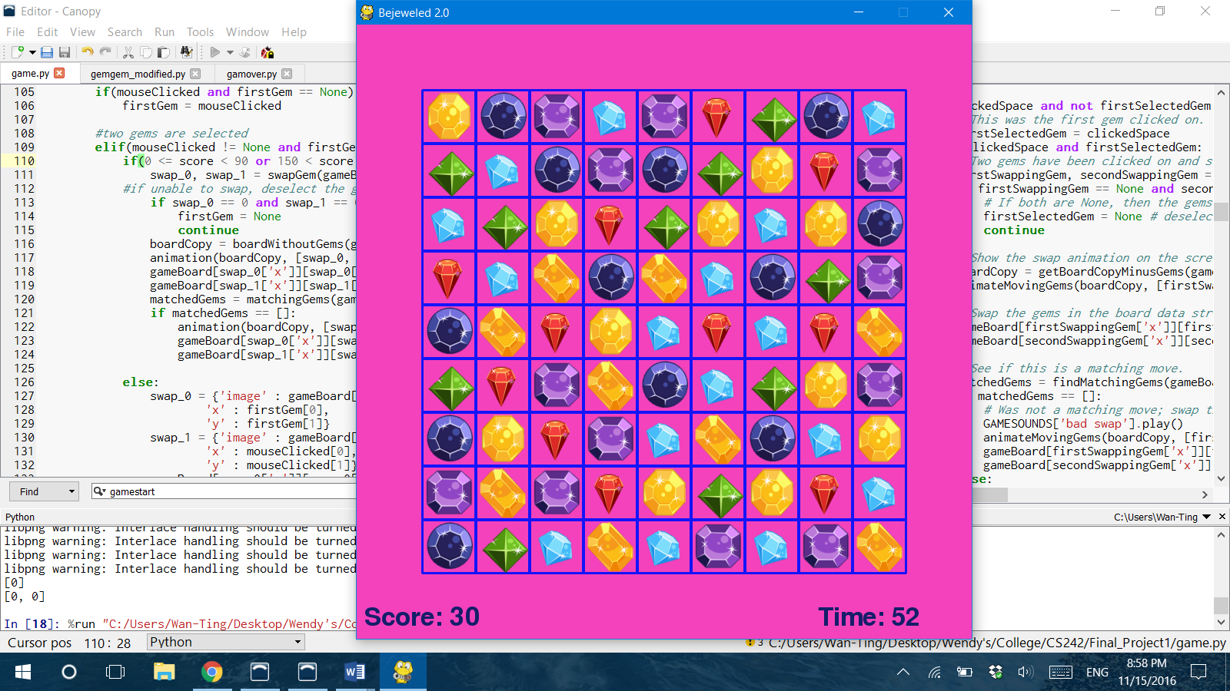

1. Super mode: When user reaches score of 200, the game enters into super mode where user can swap any two gems on the board to create links. Super mode ended when score exceeds 450.

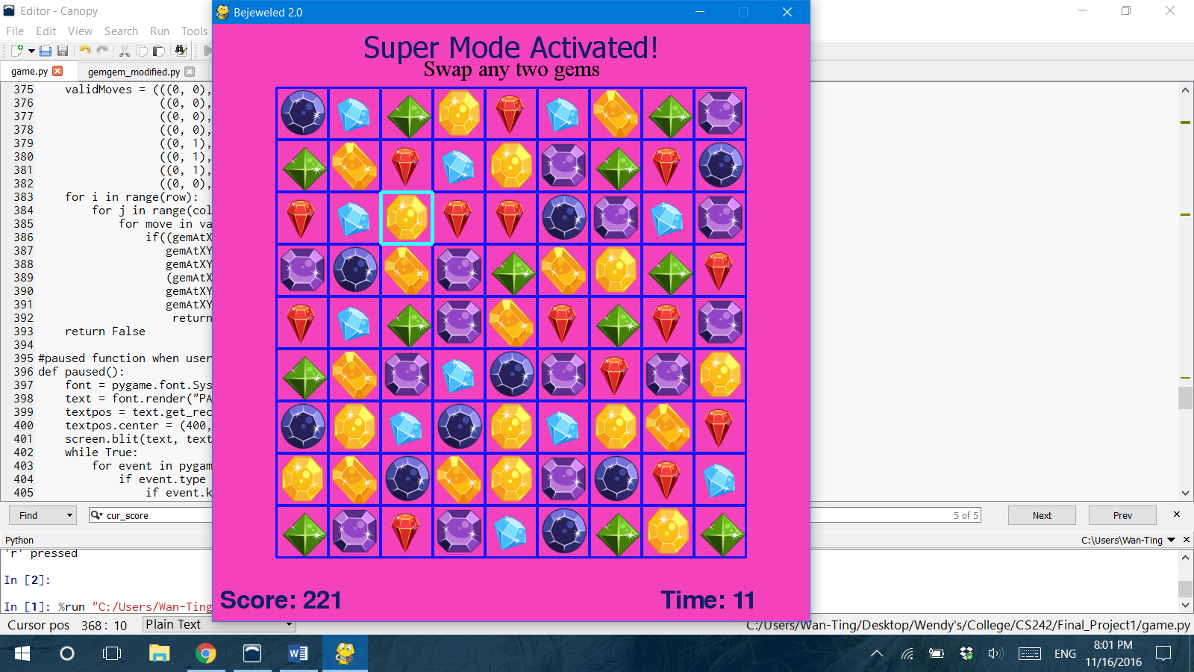

1. Scoreboard: At the end of each game, a scoreboard will appear to show the ranking of the current session.

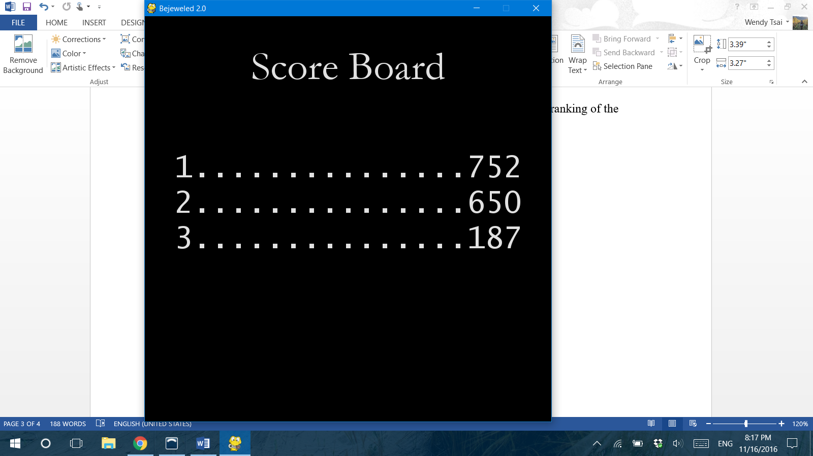

**User Interactions:**

1. Press ‘p’ to pause the game, timer will stop.

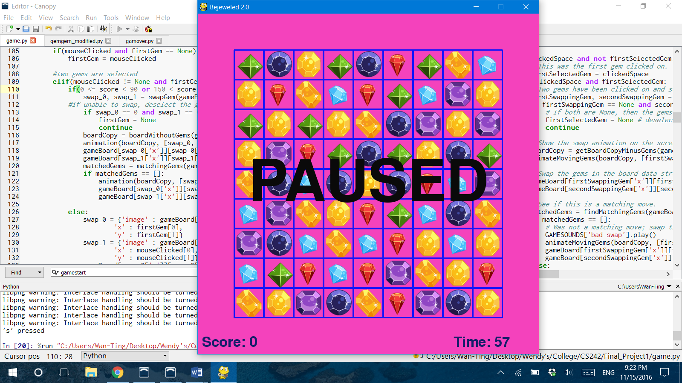

1. Press ‘s’ to resume.
2. Press ‘r’ to start a new game.
3. Press ‘esc’ to exit the game.